Assignment-3
Splitting column city and city code:
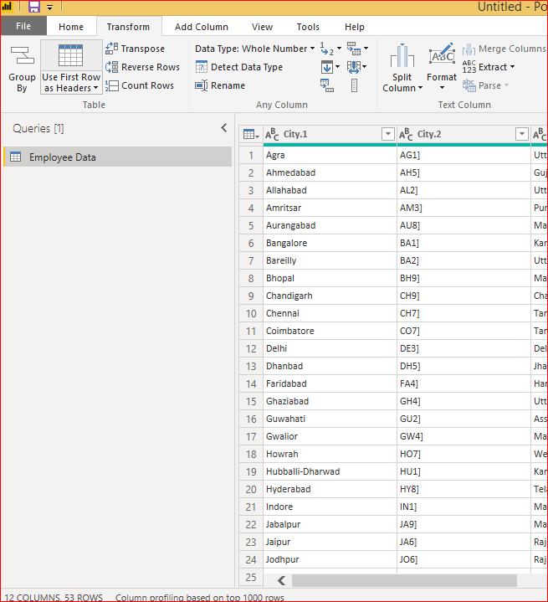

Extracting 1st name from employee name:
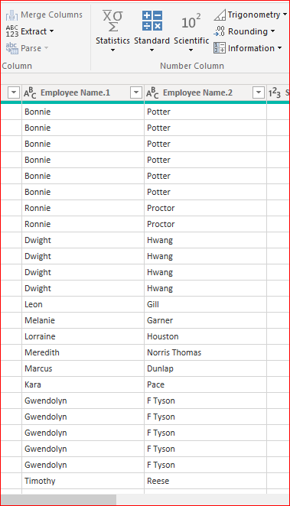

Extracting the year and no. of days in that month from given date:
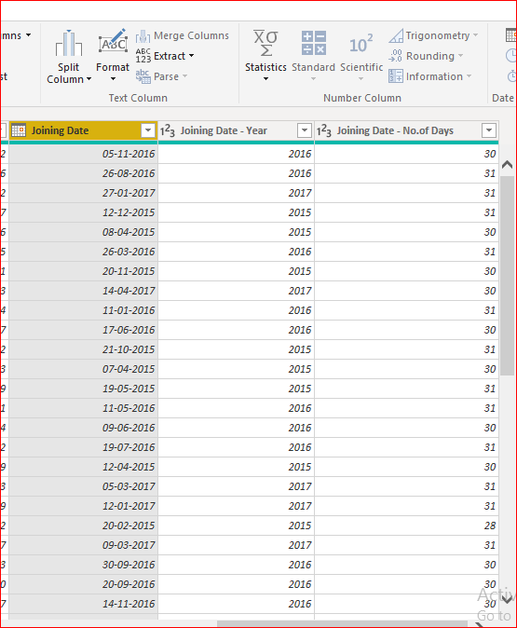

Creating a visual to show how much salary is paid to each state.
Assam and Chandigarh has the lowest payments
